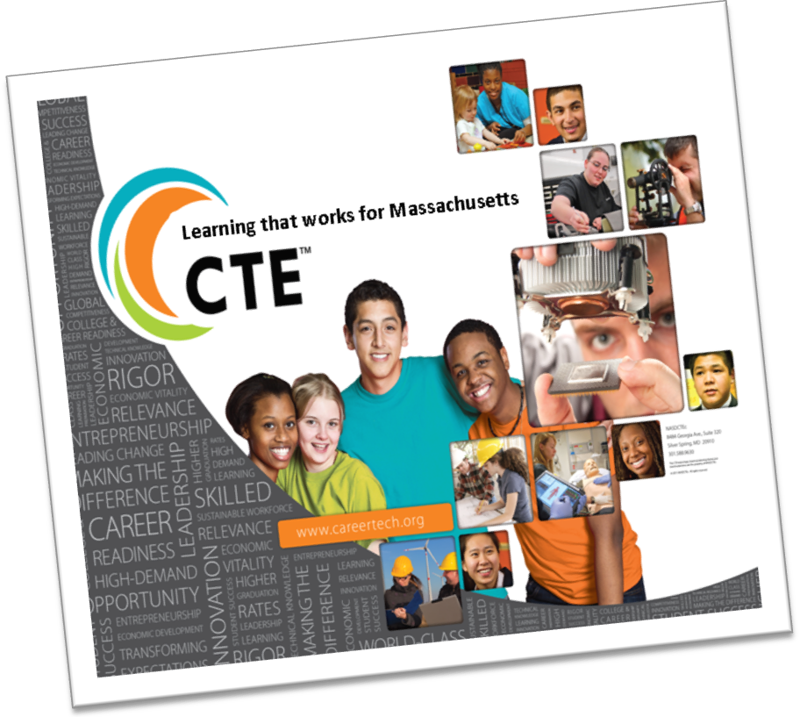

Overview

Massachusetts has signed a declaration to participate in the National Association of State Directors of Career Technical Education Consortium’s (NASDCTEc) promotional and marketing campaign, “Career and Technical Education (CTE): Learning that Works for America.”

Our statecampaign, CTE: Learning that Works for Massachusetts, can be used by educators across the Commonwealth in their efforts to increase support, awareness and advocacy for CTE.

The campaign has three primary objectives:

1. To bring clarityto CTE communications in order to enhance the ability of key audiences to better understand and appreciate the value of CTE, Career Clusters and other components.
2. To bring consistencyto the manner in which CTE communicates its brand-story and brand-value, using the same fundamental words, images and brand positioning across platforms.
3. To bring connectivity to CTE messaging that resonates with key audiences in ways that address their concerns, issues and objectives and transforms them into spokespersons and advocates for CTE.

As a leader in CTE, Massachusetts is poised to contribute outcome data that demonstrates the value of Career and Technical Education for students and their families as well as the state of Massachusetts and the nation.

Task Force Membership

In order to guide Massachusetts in rolling out this campaign, the Office of Career/Vocational Technical Education has formed a CTE Communications Taskforce that includes representation from MAVA, MVA, regional vocational technical high schools, comprehensive high schools, community colleges and student organizations.

Resources

* *videos -* <http://www.careertech.org/resources/videos.html> (*These can be modified for your school.)*
* *blog -* <http://www.facebook.com/pages/National-Association-of-State-Directors-of-Career-Technical-Education/119931471460345?v=wall> (C*onsider posting!)*
* *posters -* <http://www.careertech.org/resources/vision_toolkit.html>  *(Hang in your hallways and classrooms.)*
* *webinars -* <http://www.careertech.org/resources/webinars.html> *(Check regularly!)*

Questions? For additional information or if you are interested in participating on the Taskforce please contact Lisa Weinstein at [lweinstein@doe.mass.edu](mailto:lweinstein@doe.mass.edu) or 781-338-3955.